**1-3 Assignment: Intro to MongoDB**

Christine R. Emerson

Department of Computer Science, Southern New Hampshire University

CS-340: Client/Server Development

Dr. Vanderburgh

June 26, 2023

**Prompt**

**2. Verify Access to the environment……………………………………………………... page 2**

**3.1 Load the Database…………………………………………………………………… page 2**

**3.2 Retrieve a Document from the Collection…………………………………………... page 3**

**3.3 Find the Size of a Single Document………………………………………………….. page 4**

**3.4 Find the Size of the Collection of Documents………………………………………. page 4**

1. **Verify Access to the Environment**

**3.1 Load the Database (Mongo-Import Tool Ran Successfully)**

**3.2 Retrieve a Document from the Collection**

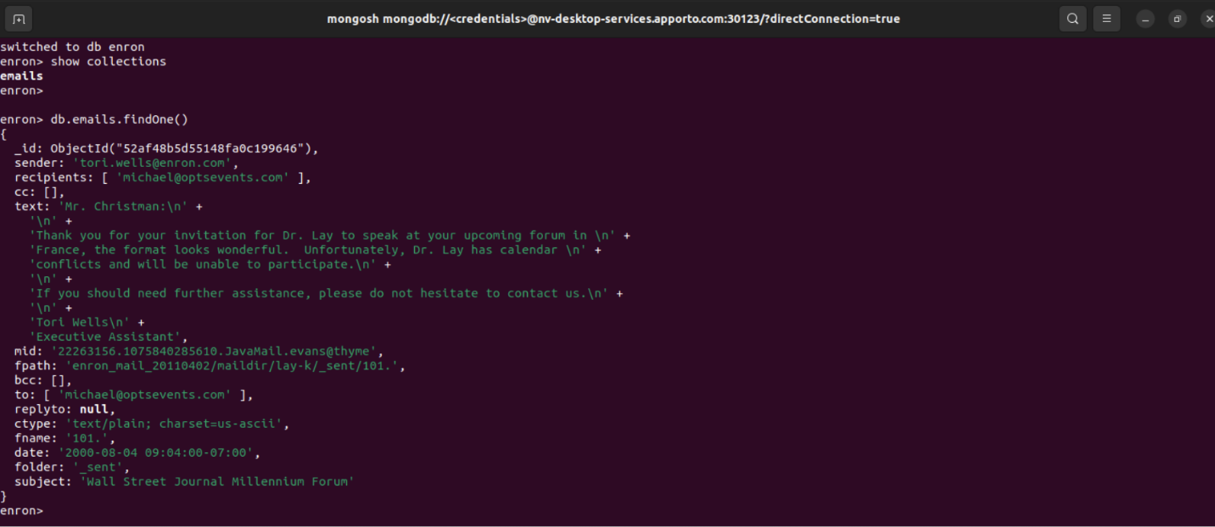

**3.3 Find the Size of a Single Document**

**3.4 Find the Size of the Collection of Documents**

